GROUP DRIVING TOURS AND RALLIES
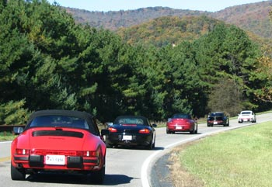
Every year the Shenandoah Region PCA organizes several group driving tours and fun rallies over the many scenic and twisty back roads in our hilly region that are perfect for Porsches. Most tours begin at 10 AM on Saturday mornings in the spring, summer, and fall. From the starting point of a tour, everyone simply follows the leader along a preplanned route to the chosen destination. There is usually a stop for lunch, and the tour group returns in the afternoon. Fun rallies differ from tours in that cars leave the starting point individually at intervals of several minutes and follow written directions instead of a lead car.

If you just want to get away for a day or weekend trip on your own, check out some of our members' favorite road trips in the Shendandoah region.
The photos on this page are from Chad's tour that started in Churchville, VA and proceeded west through the mountains to the National Radio Astronomy Observatory site in Green Bank, WV, location of the 100 meter (330 feet) diameter Green Bank Telescope. Click on the links at the bottom of this page for photos of other tours and rallies.
Adult participants must sign the waiver form that will be provided at each driving event. Minors may attend PCA events only if their parents bring the appropriate parental-release waiver forms. There are PDF forms for minors as observers only or for minors in restricted areas, riding or driving.

