2016 Diablo PCA Region Annual Summer Picnic
Sunday July 31st
From 11am to 3pm
Saint Mary’s College Moraga, Justin/Mitty Commons
$10.00 per person
Children under 12 free with a special lunch menu

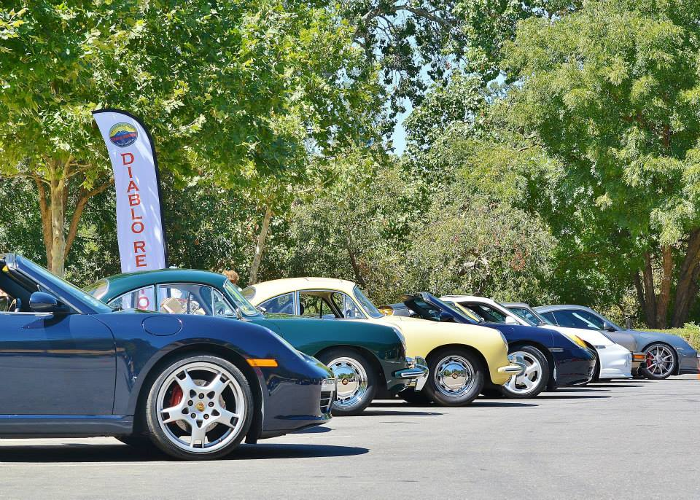

Come join the festivities at this year’s annual club picnic and car display. Lunch will be catered by Queitup BBQ. Beer, wine and soda will be available.
There will be music, mixer games, gifts and best of all fellow Porsche enthusiasts.
Register on Event bright on diablo-pca.org by July 25th.
Questions: Contact Marc Giammona at 925 -580-2413 or at mgcls@sbcglobal.net

